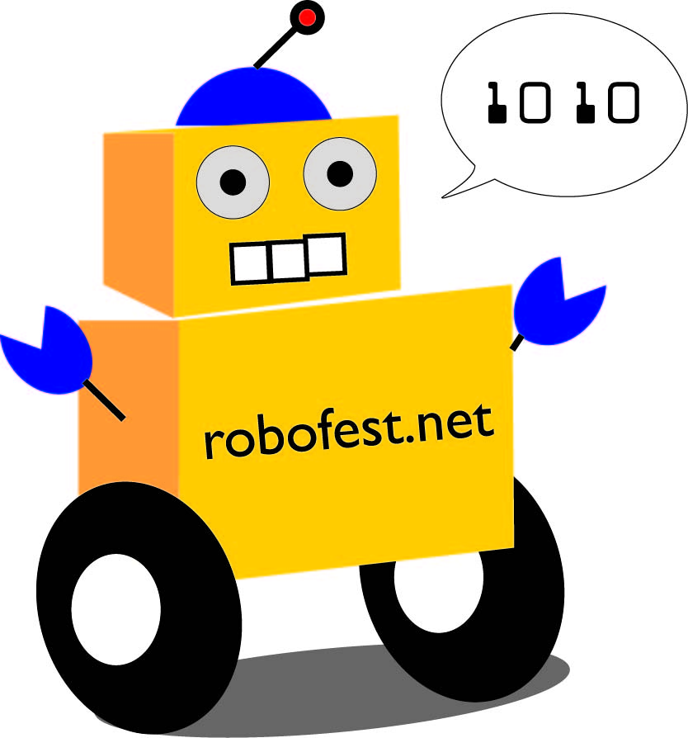 |  | 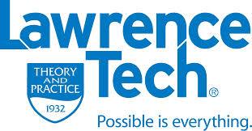
WRO-USA 2014 Tournament
July 26-27, 9:30am – 6pm
The Henry Ford Museum, Dearborn, Michigan
Teams (11)
Category | Team Name | Organization | City | Coach
Open Elementary | Los Rancheros | Munger School | Detroit | Shangaleza Robinson
 | (TB)² = To Be The Best | N/A | Beverly Hills | Knight Niki
 | STEOTW | PCA | Plymouth | Doug Chubb
 | The Martians | MARSH | Westland | Francis Feraro
 | Robogirlz | N/A | Lake Orion | Jane Tarakhovsky
 | the Green Team Inventors | Homeschool | Hamtramck | Karl Braunschweig
Open Junior | Potato | Munger School | Detroit | Tiwanya Robinson
Open Senior | The Eagle | MIT | Novi | Kurt Meister
 | Quasimotor | Farmington Harrison High Robohawks | Farmington Hills | Barry Brouillette
Regular Elementary “Demo” | Cranbrook 1 | Cranbrook Schools | Bloomfield Hills | Betsy Lamb
 | Cranbrook 2 | Cranbrook Schools | Bloomfield Hills | Betsy Lamb
Schedule
Date | Time | Events | Note
Sat 7-26 | 6:30am ~ 9:30am | Team setup
 | 9:30am | Showtime begins & Judge sign up begins
 | 10:30am | Official Presentation 1 | Teams will have max. 5 minutes for the presentation to a group of Judges
 | 2pm | Official Presentation 2
 | 4 pm | Official Presentation 3
 | 5:30pm | Judge Raffle* | Judges must be present to win
 | 6pm | Showtime ends
Sun 7-27 | 9:30am | Showtime begins & Judge sign up begins
 | 1:30pm | Official Presentation 4 | Teams will have max. 5 minutes for the presentation to a group of Judges
 | 3pm | Official Presentation 5
 | 5pm | Award ceremonies and Judge Raffle* | Judges must be present to win
 | 6pm | Showtime ends
(*) Registered Judges may win Lego NXT kits donated by Lego® Education.

What is World Robot Olympiad?
WRO is a global LEGO Robotics competition. It is an event that brings young people from all over the world together. Teams of youngsters get the opportunity to learn more about STEM and develop their creative and problem solving skills through various robotics challenges. This year 49 countries with nearly 20,000 teams are participating in this event. Each participating country has its own competition and the best teams are invited to compete at the World Robot Olympiad. The Olympic city Sochi, Russia is hosting final WRO in November 2014. Lawrence Technological University Robofest Office (www.robofest.net) is the USA National Organizer.
This year’s Open Category theme is “Robots and Space” and the task is to create autonomous robots that will assist humankind in solving tasks in space. Here at the Maker Faire Detroit as one of 8 state tournaments in the US, 9 Open Category teams are showing off their creative robotics projects related to “Space” problems.
Are you interested in competing at WRO?
For the first time ever, there are eight tournaments in CA, IL, MI, NY, OR, TX, and WA this year in the US, and it's an exciting time to be a part of WRO as it kicks off in the US!
It is not too late to form teams for WRO. There will be a Michigan tournament at Cranbrook Schools on September 6th. To register your teams, please go to www.wroboto.us.
Brief info meeting and the "Rocket" Game Workshop will be held at Lawrence Tech University in Southfield, Wednesday Aug 6, 6:30 ~ 8pm, Management Bld. M218. For questions, contact robofest@LTU.edu
Volunteer Judges Wanted Today
You can be part of WRO Right Now! You can be a Judge!
- If you are professionally engaged in Science, Technology, Engineering or Math, you are qualified to be a Judge for the WRO Open Category, “Robots and Space” Competition.
- As a Judge, you will visit 9 teams and score their presentations using the WRO rubric. It will take around one hour.
- As a Thank You from WRO-USA, you will receive a WRO T-Shirt and a cell phone credit card holder, and your name will be entered into a drawing for a Lego Robot NXT kit donated by Lego Education.
- Please sign up by filling out a form, now.
Other Autonomous Robotics Events for you!
- WRO USA final on September 27 at Lawrence Technological University in Southfield
- Halloween RoboParade® on October 25 at Macomb Community College in Warren
- GRAF (Global Robotics Art Festival) on October 25 at Macomb Community College in Warren
- Robofest 2015 season kick-off festival on December 4th at Lawrence Technological University in Southfield
To receive robotics news by email, join Robofest eNews list at www.robofest.net

