SRCC (Search, Rescue, Cleanup, and Collect Data) - Robofest® 2013 Game
V1.1 1-15-13 (Official version; Changes after Kick-off version are in red.)

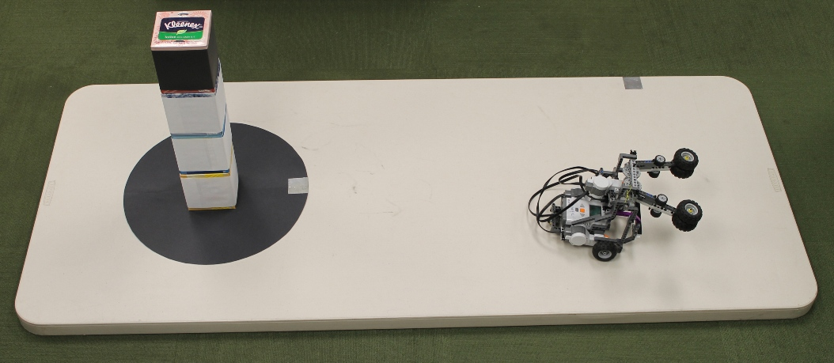
Home Base
Contaminated area
[Figure 1] SRCC playing field example (Jr. Division)

- Mission Synopsis
An autonomous robot is to search for & rescue people from a tower (trapped in a black box), collect data, and clean up a contaminated area with a tower of boxes. Detailed missions are to
Remove (clean up) the white toxic boxes from the table
Bring the black box out of the contaminated area to Home
Measure the size of the contaminated area in square millimeters and report the number
Return to the Home Base.

For Jr. Division, a black circle is used to represent the contaminated area. 2 to 3 white boxes will be used for the tower. The location of the black box will always be on the top of the tower. The number of white boxes will be unveiled 30 minutes before impounding robots.

For Sr. Division, a right triangle shape will be used instead of a circle. 2 to 4 white boxes will be used for the tower. The number of white boxes and the location of the black box of the tower will be unveiled 30 minutes before impounding robots. However, the black box will not be at the bottom.

Learning Objectives are motion, navigation, manipulation, object detection, localization, logic, ratio, proportion, math operations, measuring, and circular geometry for Jr. Division or trigonometry for Sr. Division.

- How to Play and Score the Game
Each team is given 2 rounds, 2 minutes per round. For each Jr. & Sr. age division round, the playing field configuration may be different.

Teams will be given 30 minutes after the tower is unveiled. All teams must submit their robot with a visible team ID tag to the restricted impound area when 30 minutes have expired. After impounding robots, the judges will re-set up the tables. Note that the rest of the playing field information / dimension is completely unknown and will not be announced at all.
The robot may extend its maximum width & length dimension after starting. There is no height or weight limitation. The size will be checked when the robot is impounded. Manual configuration changes made to the robot during the round must meet this size requirement. No team is allowed to download new programs for the round after impounding.

To start, a Judge (or Emcee) will specify which way (orientation) the robot will face, from 10 to 2 o’clock direction (+/- 60° of North). It can be placed in the Home Base area as long as part of it is on or over the foil tape base and it meets the size requirements; it may hang over the edges of the table. Players may pick up and modify (add and/or remove parts) their robot without penalty only when any part of the robot is on or over the Home Base (foil tape).

If any part of the robot is touched outside of Home Base by a player after the game has started, it must be restarted from Home Base and a penalty will be given. When a penalty occurs, the Judge will show a Red Card. No more than two penalties in total may be assigned per round. When restarting, the orientation of the robot should be the same direction as the game started, and the team may (1) start without reset OR (2) request full-reset of the tower. Whenever the tower is reset, a Red Card is given.

See the scoring sheet at the end of this document for detailed point and penalty values. Each team must return the robot to the impound area at the end of the round and it must remain there until the next unveiling and prep time.

- How to set up playing fields
The playing field is a 30” x 72” plastic folding table that can be purchased at discount stores like Home Depot, Kmart, or Sam’s Club. The surface is light in color such as almond; however, the exact color and brightness is unknown until the competition day. The four corners of the table are rounded. The thickness of the table is about 4.5 cm. Figure 1 shows a possible playing field configuration for Jr. Division. The table should be placed on a dark colored floor with the legs folded under.

Black 28” x22” poster board paper by ArtSkills (available at Target Stores) will be used to make the circle and right triangle shapes. https://www.artskills.com/poster-products/poster-boards/black-poster-board.html . Double-sided tape will be used under the shape to attach it to the playing field.

One 5cm x 5cm aluminum foil tape square will be placed at an unknown location along the edges of the table as the Home Base (Home). The location of Home is not too close to the corner of the table.  Unopened small Kleenex tissue boxes 11.2 x 11.2 x 12.9cm (height) will be used. The exact weight of a box is unknown. Figure 2 shows boxes covered with black and white papers. Note that the paper covers only the sides and does not cover the entire height of the box. About 1cm from the top of the box and 1cm from the bottom of box will not be covered.  Boxes will be stacked evenly. Boxes may not be parallel to the sides of the table. The orientation of boxes is unknown & random, when set/reset. | 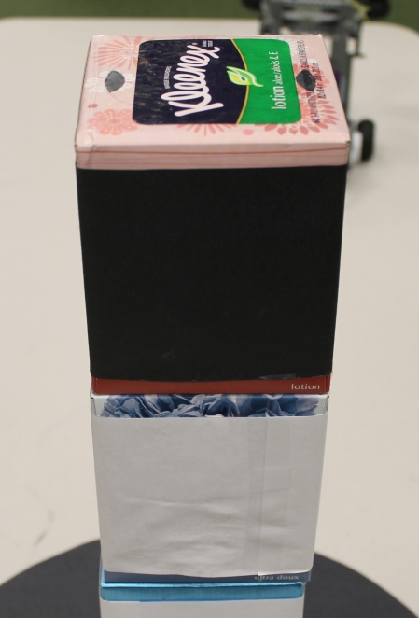  1cm  [Figure 2] Boxes covered with paper

3.1 Jr. Division Playing Field

The exact location of the circle is unknown. The minimum radius of the circle is 15cm. The location of the foil tape on the circle is unknown. The circle will be located in such a way that the distance between the edge of the table and circle edge (b, b’, b’’) will be at least 15 13cm. The location of the box tower will be near the center point of the circle. Note that the entire 5cm x 5cm foil-tape is placed inside the circle as shown in Figure 3. “a” and the horizontal distance between the Home Base and the circle, c, will be at least 20cm.
c
a
b’’
b’
b

[Figure 3] Jr. SRCC playing field diagram

3.2 Sr. Division Playing Field

Figures 4 and 5 show the Sr. Division field with a right triangle as the contaminated area. The size of the triangle is at least the size of the box and the box stack will be completely on the triangle. The 90 degree right angle will be placed on the opposite side of Home base. The size of the foil tape on the 90 degree angle is 5cm x 5cm. The angle θ in Figure 4 will be between 0 and 45 degrees. The angle C covered with the foil-tape will face the Home base direction of the table. The third angle D not covered with foil-tape will be placed toward the Home base side of the table. b, b’, b’’ will be at least 15 13cm; a, c will be at least 20cm.

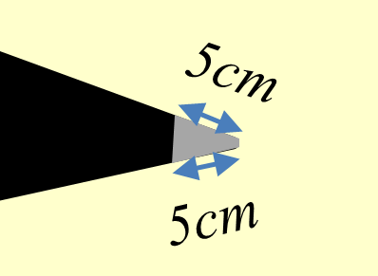
Enlarged
c
b
b’
b’’
C
D
C
θ
5cm
5cm
a

[Figure 4] Sr. SRCC playing field diagram

Robot Specifications (For both Jr. and Sr. Division)
- Initial maximum width and length is 35cm x 35cm (the robot may expand automatically after starting. The size is always checked when starting at the Home Base)
- Height and weight limitation: none
- Only one robot controller (programmable main brain) for each robot
- Any number of sensors/sensor types (unless it is harmful to humans)
- Any number/type of motors/servo motors (multiplexor is OK to use)
- Any material/robot kit may be used to construct your robot including tape, glue, bolts and nuts, rubber bands, etc.
- Team ID tag on top of the robot is required

Sr. Division Details

The difference between Jr. and Sr. Division challenges are summarized in Table 1.

 | Jr. Division | Sr. Division
Number of boxes (including one black box) | 3 ~ 4 | 3 ~ 5
Location of the black box | Always on the top | Unknown, but not on the bottom
Shape of the contaminated area | Circle | Right Triangle
Math skills | trigonometry not required | trigonometry may be required
Recommended Programming Language | GUI based (Visual programming) language | C or Java

[Table 1] Jr. and Sr. Division differences

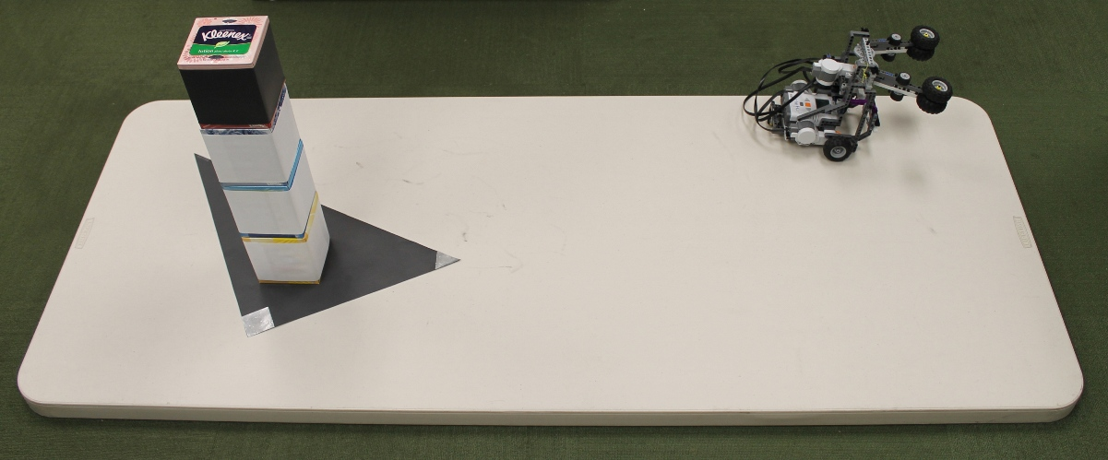
[Figure 5] SRCC playing field example (Sr. Division)

- Rules to Play Rounds and Determine Winners
The Emcee shall announce the following before each round: No adult is allowed in the pit area from now through the end of the competition. The use of any communications devices to remotely control robots or communicate with players is prohibited in this competition arena. If anyone sees any suspicious activities, please notify the nearest Robofest volunteer immediately. Only two team members can stay in the competition area.

Teams will compete in a pre-determined order decided by the site host. The Emcee will briefly introduce teams to the audience.

Winners in each division will be decided by the average Final Score of the 2 rounds. Tie breakers will be: (1) best Final Score of two rounds, (2) rerun, if needed.

- Special Notes
- Though every effort is made to be consistent and precise, in all of the dimensions of the playing field and parts, Robofest assumes some error of up to plus / minus 0.5cm. Robofest encourages feedback loop control using landmarks, not dead reckoning. Final decisions are at the discretion of the Chief Game Judge.
- If there are multiple playing fields at the competition sites, the Chief Game Judge will check consistency between the playing fields.
- Definition of coming back home: Robot “brain” (controller) part must return Home.
- When the robot is searching for the tower using distance sensor(s), Judges should maintain at least 4 feet distance from the table.

FAQs (Please check for possible additional FAQs at www.robofest.net/2013.htm)

Can teams adjust the height of the robot after the tower information is unveiled? Yes. Teams may need to bring additional parts.
- Is there a required sequence of missions? No, but “the come back to Home” task must be the last action. (In other words, when the game ends, the robot must be at Home to get the 10 points for returning home.)

Can we ask for a reset of the tower when the robot is in action? No, only when the robot is at the Home Base.

Can we ask for a tower reset without penalty when the robot is over Home Base? No. Whenever the tower is reset, a Red Card is given, if the maximum red cards have not already been given.
- The robot brought the black box back to Home. Can a player remove the box from the robot in order to try remaining missions? Yes, after getting Judge’s confirmation that the black box was saved. Give the box to Judge.
- My robot brought the black box back to Home Base. Can we ask a partial reset of the tower without the black box? No. Only full reset is allowed.
- My robot brought a white box back to Home (-10 points). Can we ask a full reset? Yes.

I grabbed my robot. Can I restart my robot without the tower reset? Yes.
- Must the robot stop at Home Base? No. It is desirable to make it stop. A player may pick it up at the Home Base without penalty.

Do the Judges stop the clock to reset the tower? No.
- Can a robot still display the area after the 2 minute time runs out? Yes.
- Can a player reset the tower? No. It must be done only by Judges. Remember: you will be asked to restart if you touch the tower boxes. A penalty will be assessed.

Bill of Materials (BOM) to Construct a Playing Field
 | Est. Unit Cost | Quantity | Cost
30” x 72” Folding Table; Suggested tables can be found at: http://www.buylifetime.com/Products/BLT/PID-22901.aspx; Almond color; Folding tables will be re-used in future Robofest games. Note that the thickness of the table is about 4.5cm. | $80 | 1 | $80
Small Kleenex boxes for the tower (store brands such as CVS tissue boxes may have the same dimensions) | $2 | 4 | $8
White letter-size paper to cover the boxes |  | 8 | N/A
Black letter-size paper to cover the boxes |  | 2 | 0.10
Scotch tape or double sided Scotch tape |  | 1 | N/A
Black 28” x22” Poster Board by ArtSkills at Target | $0.77 | 1 | 0.77
Aluminum foil tape at Home Depot or Lowes | $7 | 1 | $7
Total |  |  | $95.87

Robofest 2013 SRCC Challenge Scoring Sheet (v1.21)

Division: Junior / Senior Team Name: ___________________________

Team School / Organization Name: ____________________________ Team Number: ________

Round: First Second Track No.: _________

Judging Items (checked at the end of a game round) |  | Count | Point Value (per count) | Score Earned / Lost
Black Box | Off the table (or touching the floor) | 0 1  (no) (yes) | -15
 | Still inside or touching the contaminated black area | 0 1  (no) (yes) | -5
 | On the table, but not touching the black area | 0 1  (no) (yes) | 15
 | On or held by the robot, not touching the table at Home; (or in possession of Judge when the box was saved and removed during the game) | 0 1  (no) (yes) | 20
White Box | Off the table (or touching the floor) | 0 1 2 3 4 | 10
 | Still inside or touching the contaminated area | 0 1 2 3 4 | -5
 | On the table, but not touching the black area | 0 1 2 3 4 | 5
 | At or on the Home Base | 0 1 2 3 4 | -10
The robot came back Home by itself at the end. |  | 0 1  (no) (yes) | 10
The robot measured the contaminated area, and reported the area ___________________ (Measured Value) in mm² at Home or after the game. |  | 0 1  (no) (yes) | 35
The robot remained intact throughout Game. |  | 0 1  (no) (yes) | 5
Number of Red Cards that were given when a human player touched the robot or the tower was reset |  | 0 1 2 | -5
**  If Measured Value was “blank”, Final Score is Total Score.  If Measured Value is a number, calculate $e=\frac{\left| CorrectValue-MeasuredValue \right|}{CorrectValue}$  Final Score = $\left\{\begin{aligned}\begin{matrix}Total Score-32 & if e≥1.0\end{matrix} \\ \begin{matrix}Total Score-30*e & otherwise\end{matrix}\end{aligned}\right.$ |  | Total Score  Max. possible is 100, if 3+1 boxes used

Final Score **
Calculated by Scorekeeper using Excel. Not to be rounded.

Judge initials: ____________________ Team player initials: __________________________

